Progress, Status, and Management Monthly Report
Contract | FA8730-21-D-0001/FA####-##-X-####
Deliverable Number | XX
CDRL | A006 – Progress, Status, and Management (PSM) Report
Project Duration | [Start date] – [End Date]
GTRI Project Number | DXXXX
Project Title | [Title]
For period | 1 August 2021 – 31 August 2021
Submitted by | GTRI PD(s)
Date Prepared | [Date Prepared]

Task 1 | Systems Engineering
Task 2 | Configuration Management
Task 3 | Logistics Management

Highlights
Task # | Description | Benefit to HBG
Task # | Description | Time | Cost | Technical
1 | Developed simplified “radar equation” based model that generates similar outputs to TAP model with PHaRLAP HF ray datasets | ☒ | ☒ | ☒
2 | Presented MBSE Strategy to EN Roundtable. | ☒ | ☒ | ☒

Detailed Performance by Task Reporting

Task 1 | Systems Engineering

Activities and Accomplishments for Period
- .
Travel for Current Reporting Month
- .
Research Goals/Plans for Next Period
- .
Issues and Concerns
- .
Task Number | Engineering Labor  Category | Number of Individuals | Current Month Total Hours
1 | Principal Research Engineer | 1 | 15
1 | Senior Research Engineer | 3 | 96

Task 2 | Configuration Management

Activities and Accomplishments for Period
- .
Travel for Current Reporting Month
- .
Research Goals/Plans for Next Period
- .
Issues and Concerns
- .
Task Number | Engineering Labor  Category | Number of Individuals | Current Month Total Hours
2 | Principal Research Scientist | 1 | 48.5
2 | Principal Research Engineer | 1 | 5
2 | Senior Research Engineer | 2 | 87
2 | Research Engineer II | 1 | 74
2 | Research Engineer I | 3 | 469.9

Task 3 | Logistics Management

Activities and Accomplishments for Period
- .
Travel for Current Reporting Month
- .
Research Goals/Plans for Next Period
- .
Issues and Concerns
- .
Task Number | Engineering Labor  Category | Number of Individuals | Current Month Total Hours
3 | Senior Research Engineer | 1 | 32

Cumulative Cost Report for All Tasks
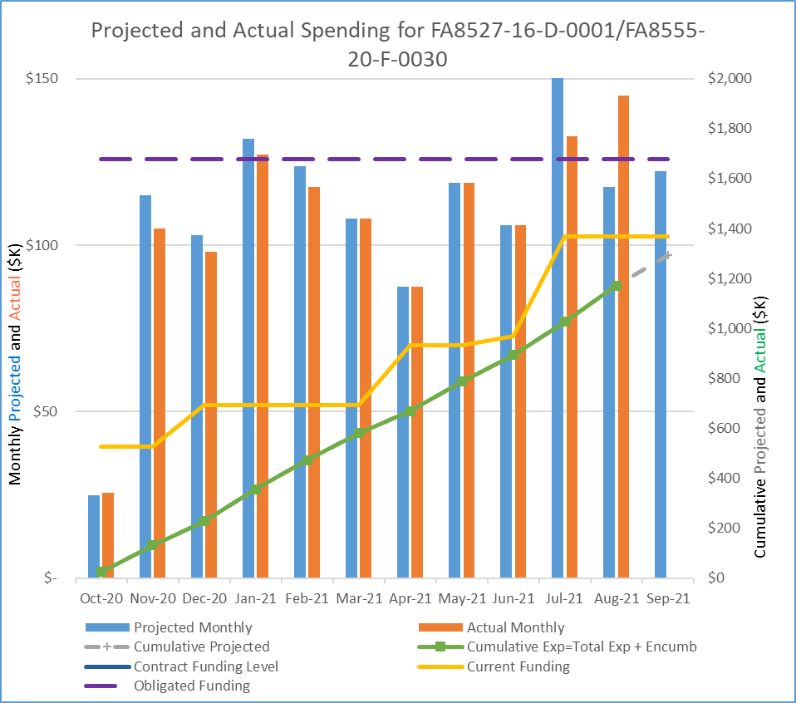
Task Title | Engineering Labor  Category | Number of Individuals | Current Month Total Hours
ALL Total | Principal Research Engineer | 2 | 20
ALL Total | Principal Research Scientist | 1 | 48.5
ALL Total | Senior Research Engineer | 4 | 215
ALL Total | Research Engineer II | 1 | 74
ALL Total | Research Engineer I | 3 | 469.9
Grand Total |  | 11 | 827.4

